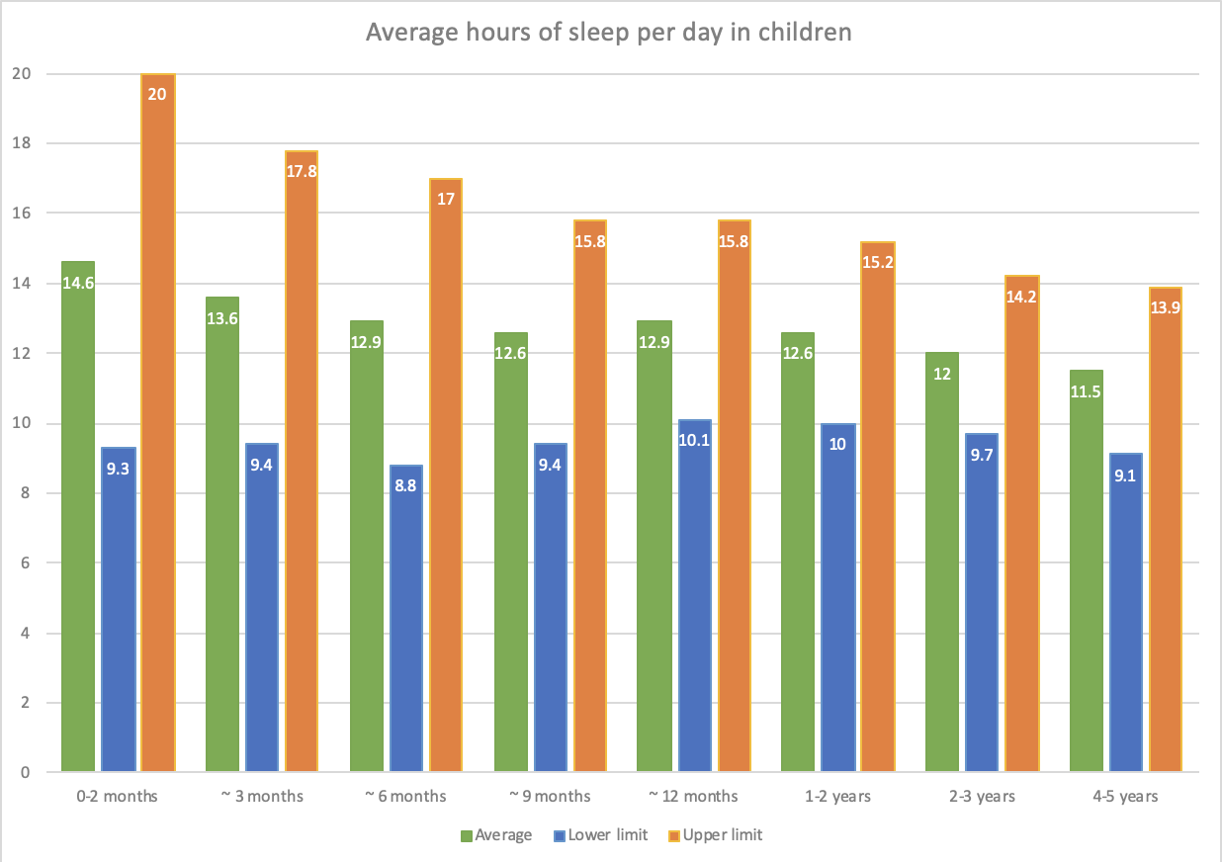

Sleep duration in children
Galland B, Taylor B, Elder D
Normal sleep patterns in infants and children: A systematic review of observational studies
Sleep Medicine Reviews, July 2011. This study is available online here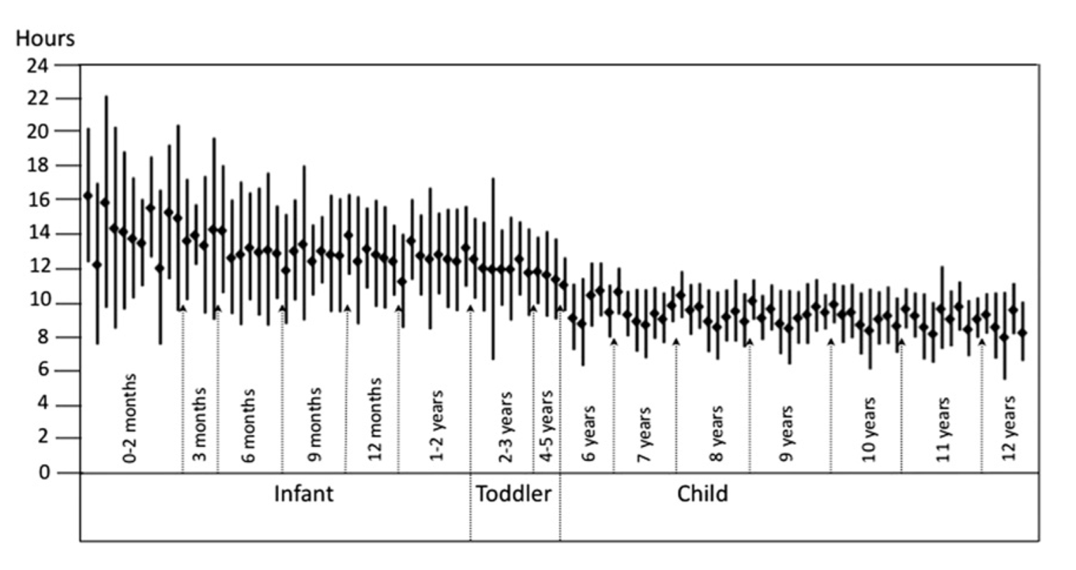
Fig. 3. Plot of the sleep duration data across age categories from all the studies reviewed for this variable. Data are presented as the mean +/- 1.96 SD.

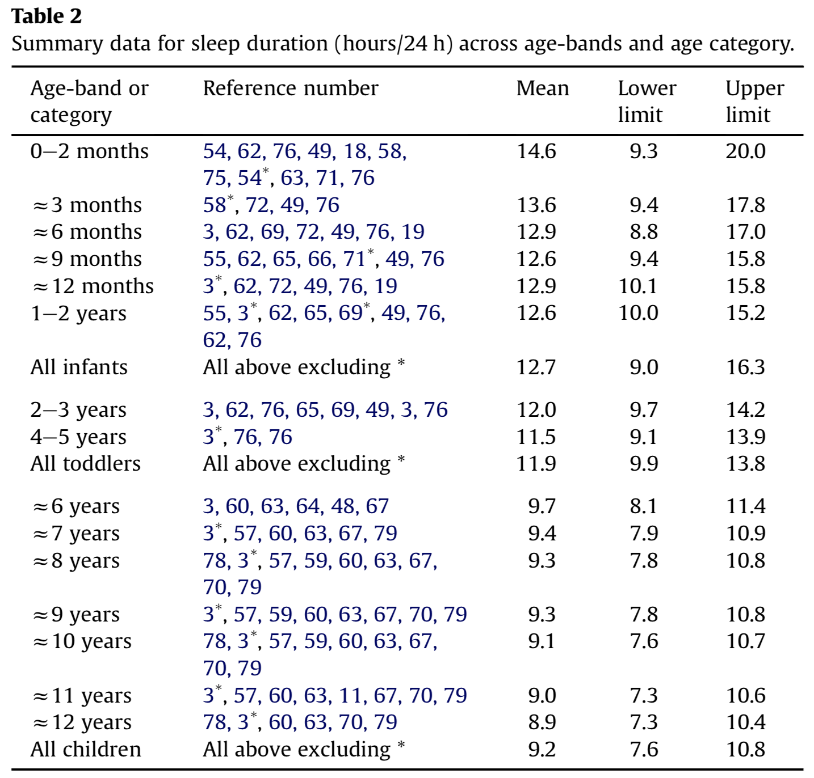

Source

